EE3011.ELECTRONICS 1

Experiment (5) Diode Rectifier with Peak Detector Lab Report

(Section A)

Mehmet Akif Türkmenoğlu
150720061

Part (1): Half-wave Rectifier Output Analysis
In the first part of the experiment, we created the circuit in Figure 1 with just N4001 type diode, 1kΩ resistor and V_{S} (10 V, 60 Hz, sinusoidal). In the oscilloscope, we wanted to show two output waveform and to do that we use both channel of the oscilloscope. Channel 1 displays the V_{S} value at the top and channel 2 displays V_{o}
value at the bottom.
Figure 1: Half-wave rectifier with peak detector and regulator

Part(1.1): LTSpice Transient Analysis
I created the circuit in LTSpice that looks like this:
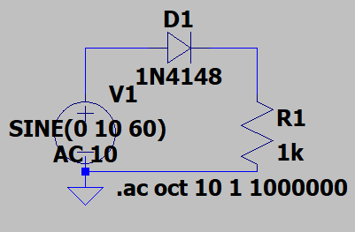
Figure 2. Circuit for Part(1) in LTSpice

Here is the analysis of the circuit:
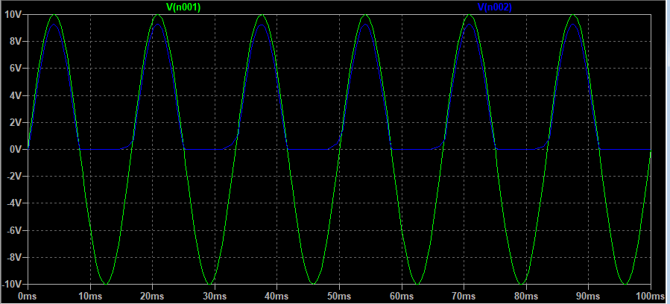

Part(1.2): Lab Results
Here is the circuit that I did in the lab:
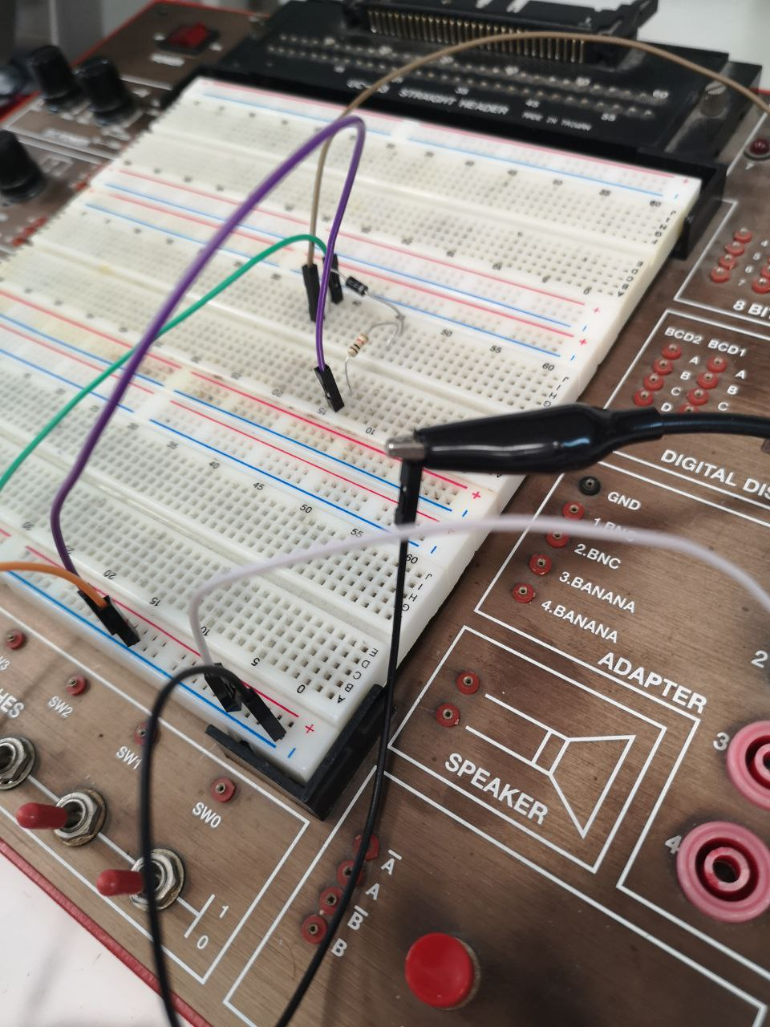
Figure 3. Circuit for Part(1)
And I want to state that; there is autoscaled oscilloscope display below. I resized both of the graphs as 5V/ because I wanted them to display in the same size rate for better comparison. So the photos below are actually the same but second one has the signals in the same size rate. For the rest of the report I added the oscilloscope results as in the same size rate.
I also measured the voltage of V_{o} with multimeter.
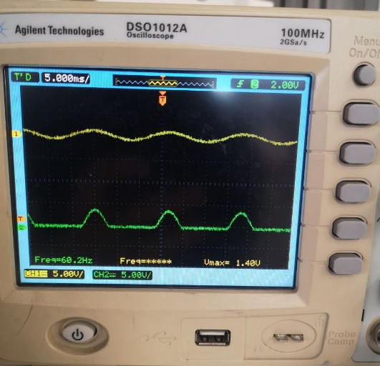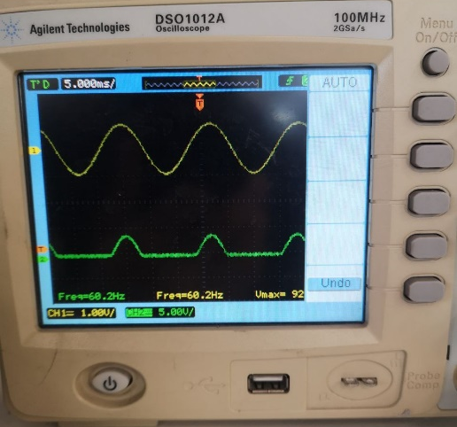

Figure 4. Vs (at the top) and Vo (at the bottom) Figure 5. Vs (at the top) and Vo (at the bottom)
[autoscaled] [in the same size rate]

- Calculate the theoretical value of the average output voltage and record it in table 2.

Sinusoidal input

V₀ (ave) (V)  Experimental Value | V₀ (ave) (V)  Theoretical Value | %  Difference
9.2276 V | 9.24 V | 0.01
Table 2. Average output voltage of the half-wave rectifier without peak detector.
- Comment on your results regarding the waveforms in graphs 1 and 2.
In the oscilloscope, first graph represents the waveform of the sinusoidal voltage and the second graph represents the output of the diode. It behaves as a half-wave circuit as expected.
- Comment on your results regarding the average output voltage.
What I observe from the graph is diode blocks the negative side of the sine wave and decreases the amplitude of the sine wave.

Part (2): Half-wave Rectifier with Peak Detector and Regulator
For this part, I created the circuit in Figure 1 with capacitors connected and monitor their waveforms. Then, I added Zener diode to the circuit and observed the waveforms. For the simulation part, there is no 1N4001 and 1N4072 type diodes in LTSpice so I used 1N4148 type for both of the diodes as previous weeks.

Part(2.1): LTSpice Transient Analysis
In LTSpice, I created the circuit with 100 µF capacitor and its output waveform is displayed as:
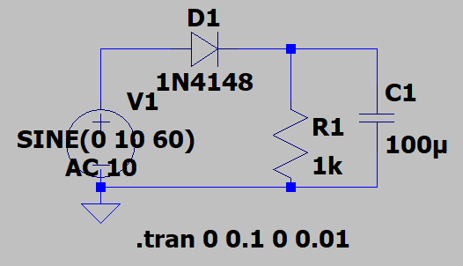
Figure 6. Circuit with 100µF Capacitor Connected in LTSpice
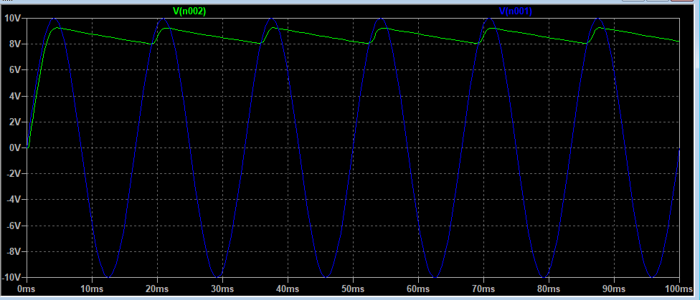
Figure 7. Output Waveform of the Circuit in Figure 6 in LTSpice

Then, I created the circuit with 100 µF capacitor in LTSpice and its output waveform is displayed as:
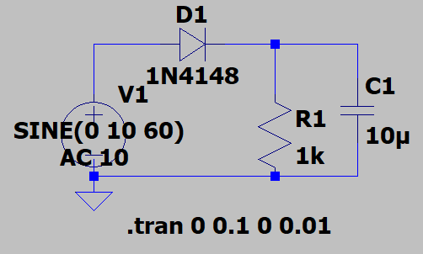
Figure 8. Circuit with 100µF Capacitor Connected in LTSpice

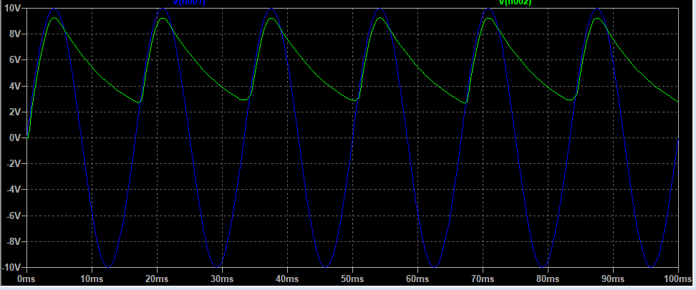
Figure 9. Output Waveform of the Circuit in Figure 6 in LTSpice
Then I added another diode as in Figure 1 and simulate the circuit in 100µF and 10µF capacitors respectively. Here are the results:
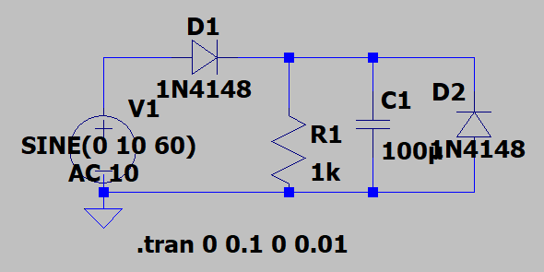
Figure 10. Circuit with 100µF Capacitor and Zener Diode Connected in LTSpice

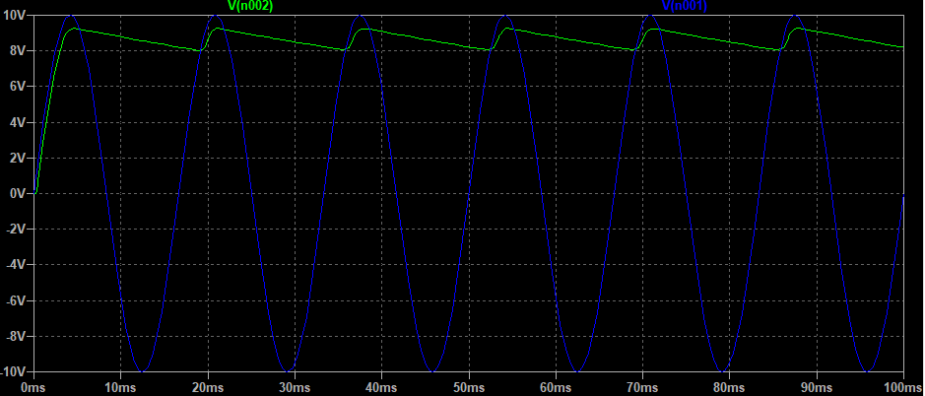
Figure 11. Output Waveform of the Circuit in Figure 6 in LTSpice

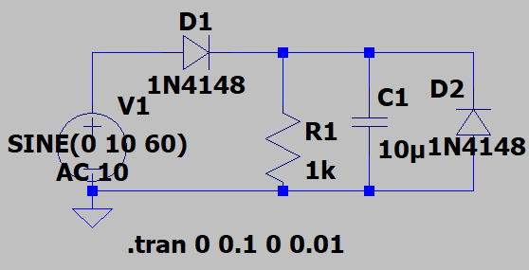
Figure 12. Circuit with 10µF Capacitor and Zener Diode Connected in LTSpice

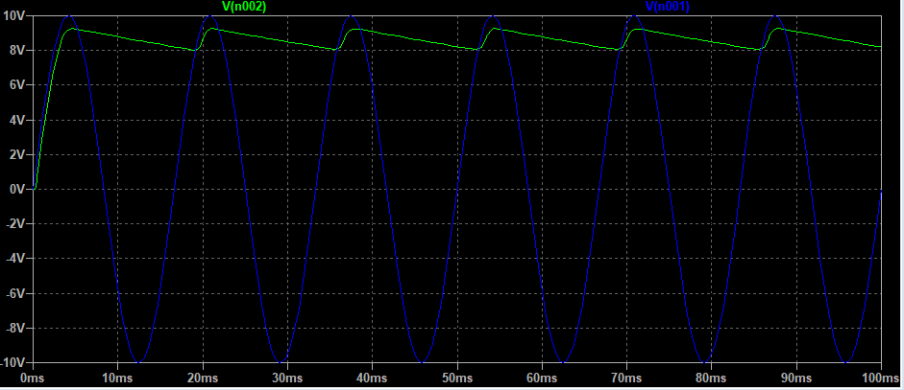
Figure 13. Output Waveform of the Circuit in Figure 6 in LTSpice

Part(2.2): Lab Results
Here is the circuit with 100 µF capacitor and its output waveform:
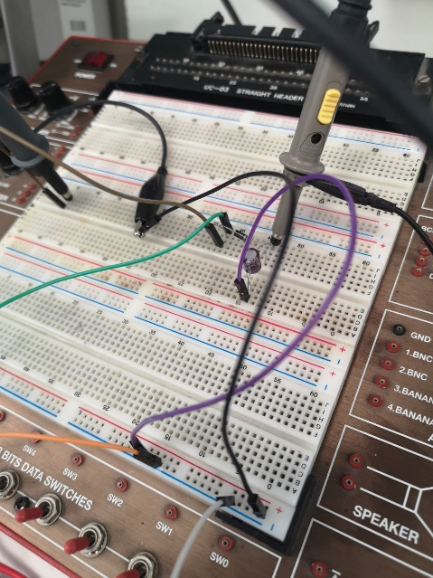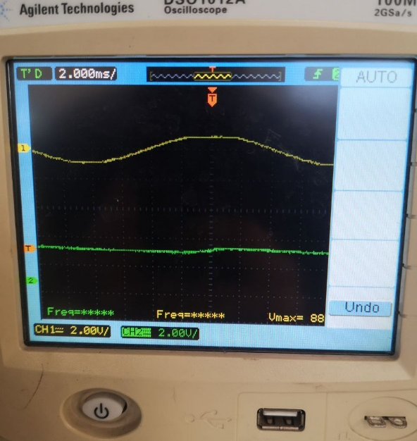
Figure 14. Circuit with 100µF Capacitor Connected Figure 15. Output Waveform of the Circuit in Figure 14
And here is the circuit with 10 µF capacitor and its output waveform:
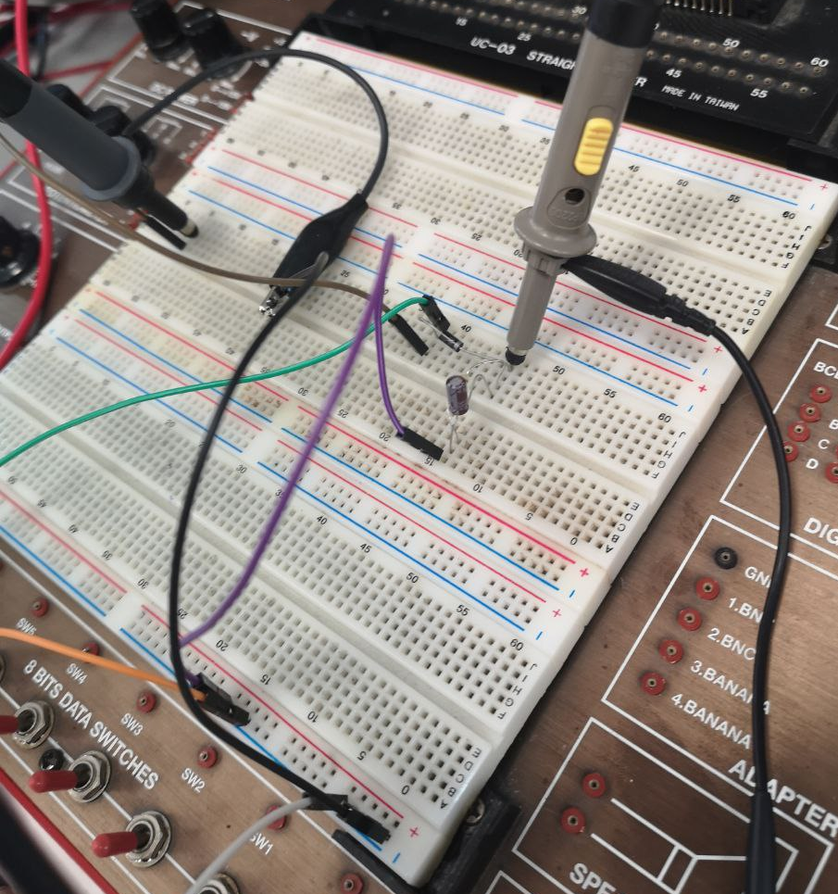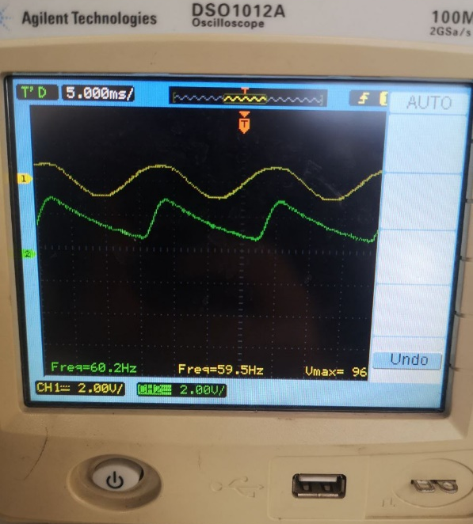
Figure 16. Circuit with 10µF Capacitor Connected Figure 17. Output Waveform of the Circuit in Figure 16

Finally I connected the Zener diode to the circuit with different capacitors and observe the waveforms.
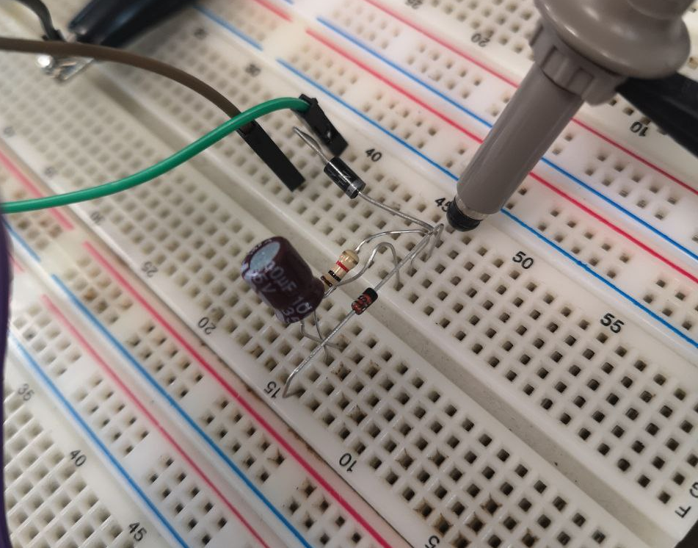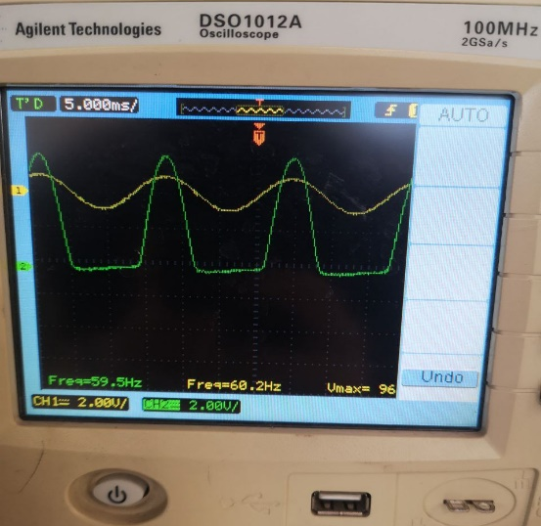
Figure 18. Circuit with 100µF Capacitor Figure 19. Output Waveform of the Circuit in
Connected (Zener) Figure 18

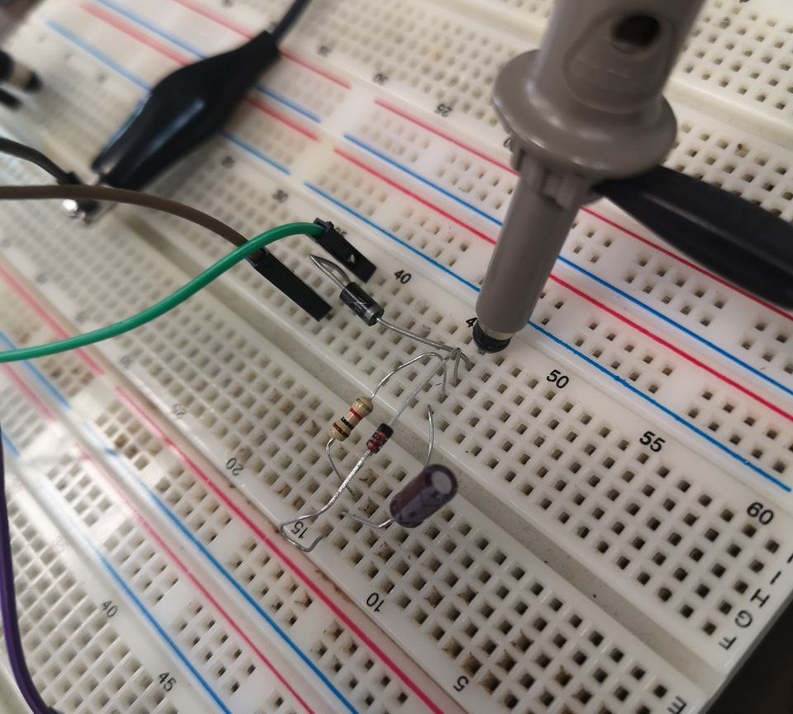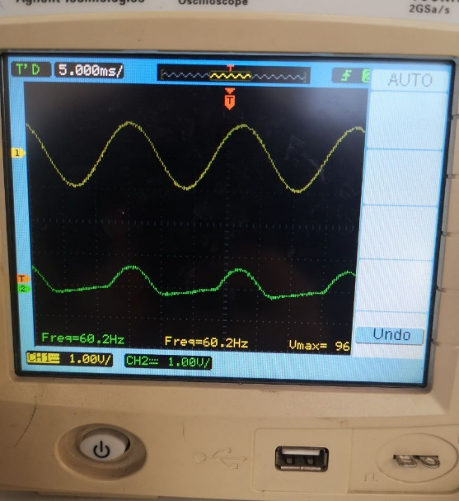
Figure 20. Circuit with 100µF Capacitor Figure 21. Output Waveform of the Circuit in
Connected (Zener) Figure 20

- Calculate the theoretical value of the average output voltage and record it in table 3.

 | Sinusoidal input
Capacitor value (µF) | 𝑉0 (ave) (V) Experimental value | 𝑉0 (ave) (V) Theoretical value | %  Difference
100µF | 9.238 | 9.26 V | 0.01
10µF | 9.246 | 9.26 V | 0.01
Table 3. Average output voltage of the half-wave rectifier with peak detector.

- Comment on your results regarding the waveforms in graphs 1 and 2.

I see that the voltage signal of V_{o} decreases instantly after a point and this distorts the shape of sinusoidal voltage. Other than that, the difference between the circuits with different capacitors and with the zener diode is not so clear.

- Comment on your results regarding the average output voltage.

As in Part(1), the diodes block the negative side of the sinusoidal voltage and keep the positive sides. But this the shape of average output voltage is not regular, there is abrupt decrease in the waveform.

